LAB 08 Answers  
Markov Decision Process (MDP)

Modifications

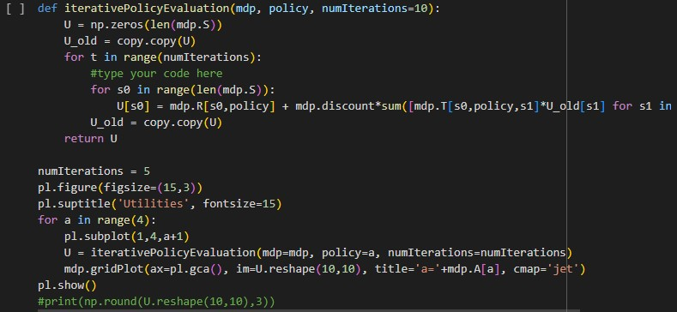

GridWorld

Modification

Environment grid

02

**Step 2: Explanation of Model-Based vs. Model-Free Algorithms**

**Model-Based Algorithms**

* **Definition**: These algorithms assume a known model of the environment (i.e., transition probabilities and rewards) and use this model to compute the optimal policy.
* **Example**: **Value Iteration**, **Policy Iteration**.
* **Advantages**: Directly uses the model to plan, can be efficient in stationary environments.
* **Disadvantages**: Requires knowing or learning the model (transition and reward functions).

**Model-Free Algorithms**

* **Definition**: These algorithms do not assume a known model of the environment. Instead, they learn the policy directly from interactions with the environment (e.g., Q-learning).
* **Example**: **Q-Learning**, **SARSA**.
* **Advantages**: Can be used in environments where the model is not available or too complex to calculate.
* **Disadvantages**: Usually slower to converge because it relies on sampling to learn.